Section | Issue Identified | Required Revisions
Africa’s Health R&D Agenda | Image beside title not final | Replace with any 3-5 images into a carousel from Google Drive ( Website landscape images folder)
Vision Statement | Incorrect wording | Should be Saving lives through health research, innovation, and development.
Mission Statement | Incorrect version | Replace with, To catalyze action on health R&D through coordinated advocacy efforts to facilitate access to safe and efficacious health products technologies and innovations to communities in Africa
Flagship event- Culture of Science image section | Eastern Africa regional Global Image needs replacing | Replace with updated images from Drive (COS Square banner file)
Engagement Zone | Images need replacing | Replace with updated images from Drive (Stock photos folder)
Key Moments | Title | Change to: Culture of Science Key Moments
The Science action Agenda | Pre-empts conference outcomes | Replace with Science Action Agenda overview from the Chread.africa site
Photo carousel under Science Action Agenda | 2 of the generic Images | Replace with CHReaD speaker images from drive (Website individual images folder)

CHREAD WEBSITE & CULTURE OF SCIENCE CONFERENCE PAGE
REVISION BRIEF

- CHREAD WEBSITE REVISIONS

- Home Page

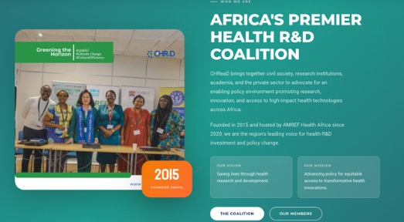
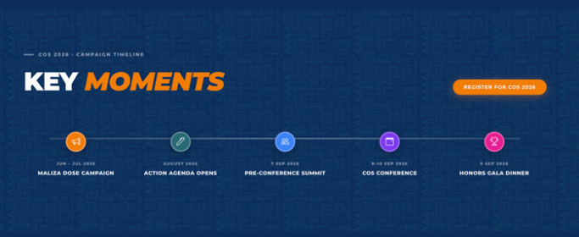

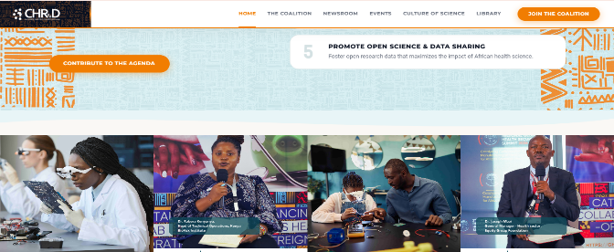


- Coalition Section

Section | Issue Identified | Required Revisions
Membership Categories in the membership application | Missing student category | Add Student Membership in the membership category
Thematic Priorities | Those are CoS thematic priorities | Remove the section
Governance Framework | Incorrect structure | Instead, include: Steering Committee, Subcommittee, Secretariat, Members, and remove descriptions
What We Do | The current section contains 6 over fragmented pillars | Replace with Advocacy Across the Full R&D Value Chain details from Chread.africa site

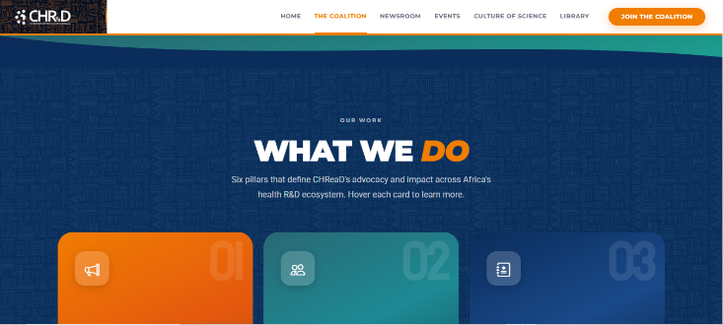
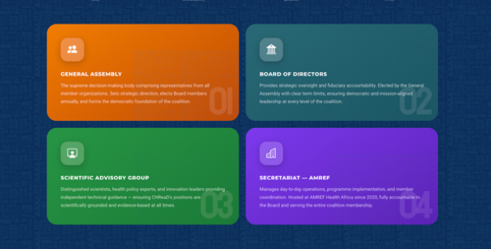

- Events Section

Section | Issue Identified | Required Revisions
Date included in the description under the Culture of Science heading | Not clearly detailed | Improve or redesign event date display and add location: 8–10 Sept 2026, Amref International University, Nairobi

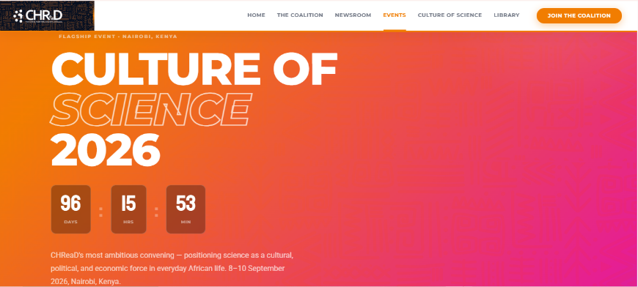

- Library Section
Section | Issue Identified | Required Revisions
Available documents | The preview currently uses icons (policy, data, graph icons) | Replace static icons with document preview thumbnails showing the first page of the document

- CULTURE OF SCIENCE CONFERENCE PAGE

Section | Issue Identified | Required Revisions
Page’s first Image showing a female scientist | Gender imbalance | Use photo of both gender scientists or rotating scientist images
Inquire to Attend CTA Button | Incorrect label | Change to Register to Attend
Conference Engagement Zones | Missing exhibitor inquiry button | Add exhibitor button
Gala Dinner | There is no registration method for the dinner | Add registration button
Reserve your seat inquiry section | Wrong CTA label | Change Inquiries to Registration
In collaboration with Conference Partners | Missing logos | Logos are included in Drive, numbered in the order in which they should be placed (CoS Partner Logo folder)



